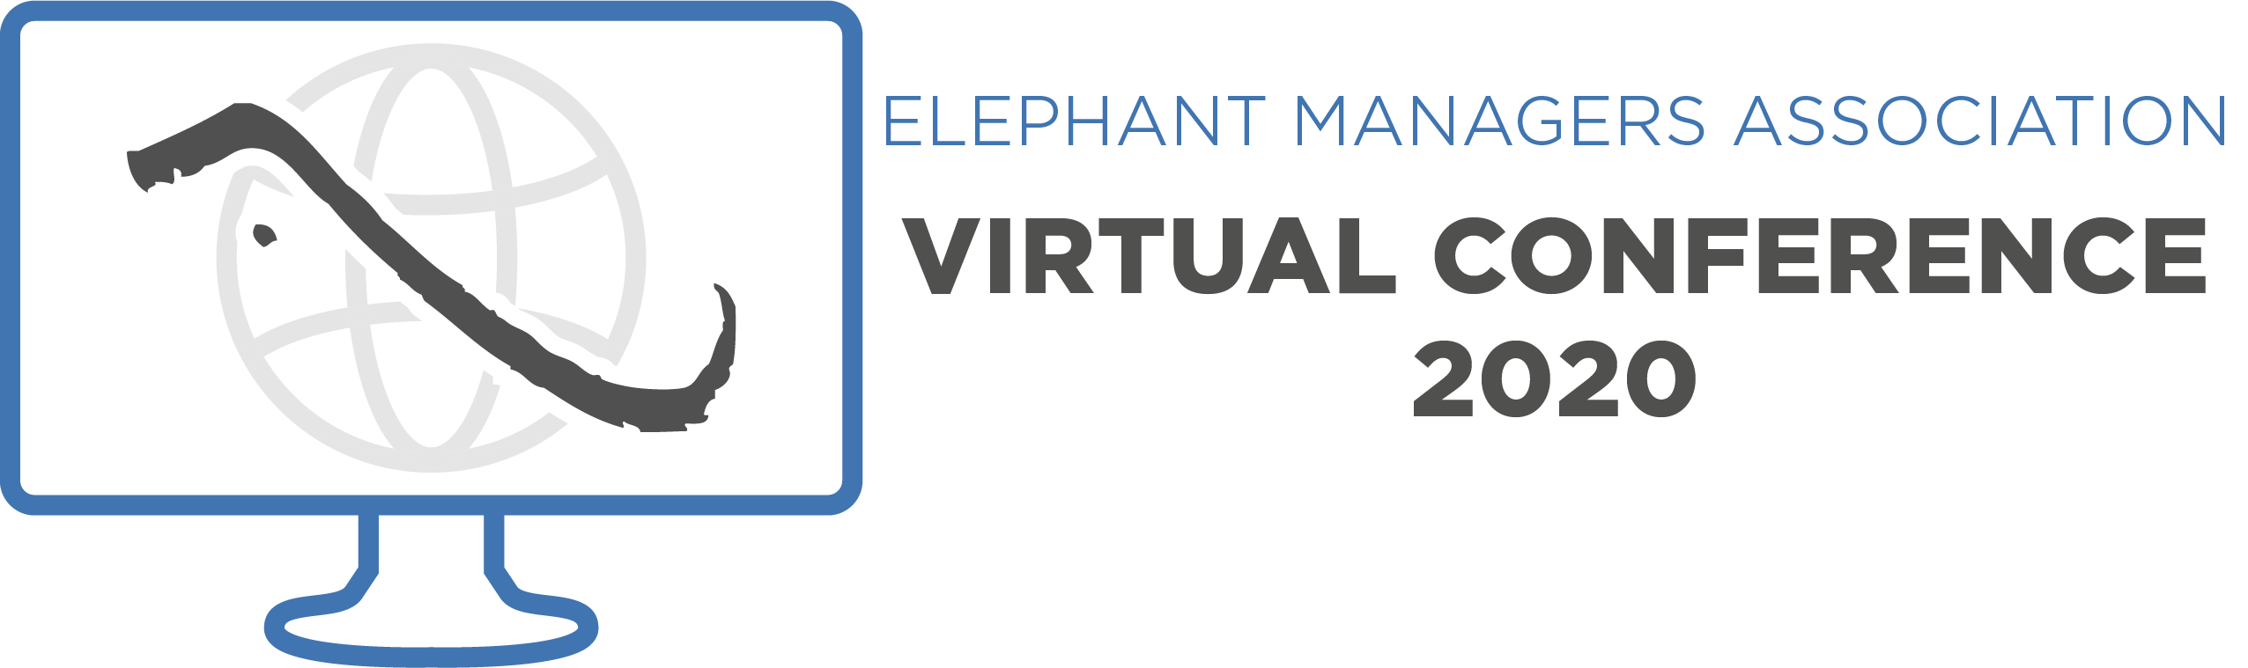

41st Annual Elephant Managers Association Virtual Conference
October 12–16, 2020

The Elephant Managers Association is seeking abstract submissions on all aspects of elephant care and management. To submit a paper, please complete the form below, including the abstract, and submit via email to Jessica Scallan at jscallan@tulsazoo.org. Abstract submissions are due by September 1, 2020.

Name of Presenter:
Job Title:
Organization:
Mailing Address:
Phone:
E-mail address:

If your abstract is accepted, please indicate below which material(s) you will allow EMA to share with its members in the conference proceedings. These materials remain the intellectual property of the presenter and/or their institution and are only accessible to EMA members.

Abstract of my presentation
Slides from my presentation (in PDF form)
Video of my presentation
I do not wish to share any materials

Special Requests:

Presentation Title:
First Author:
Institution:
Co-authors:
Type or copy/paste abstract below:

